***2014 Sponsor’s Guide***

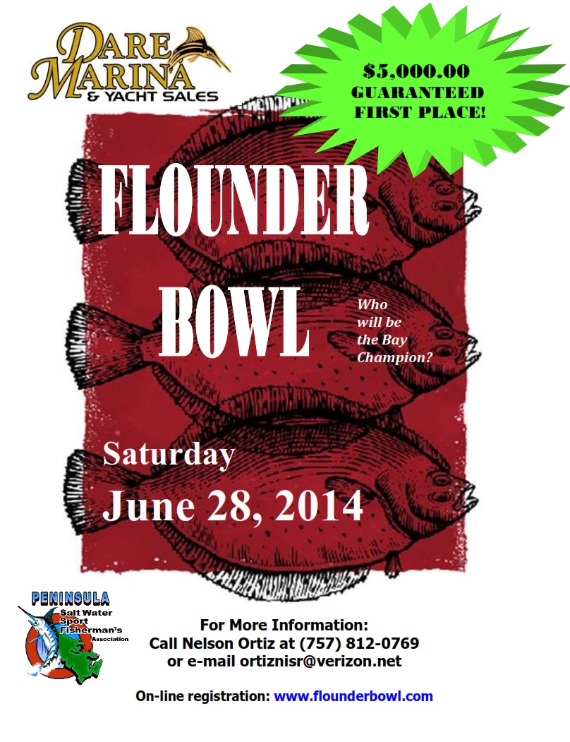

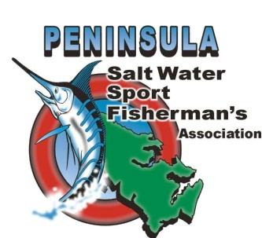***Your 2014 Flounder Bowl Sponsorship***

The Peninsula Salt Water Sport Fisherman's Association is a not-for-profit fishing club that hosts a variety of events each year. Our events are family and community oriented, all with the common goal of promoting responsible sport fishing along our coast, responsible conservation measures and family recreation in the outdoors. As we begin the 2014 fishing season, we would like to take the time to thank our 2013 sponsors and to request your sponsorship of our annual flounder fishing tournament.

For over fifty years our club has participated in, organized and hosted family and community-related fishing events. We have been actively involved in giving back to the community through fishing clinics for underprivileged children and similar outdoor-related activities. Our 400+ members volunteer hundreds of hours each year to support these activities, to sit on fisheries management advisory boards and to help conduct fisheries research.

Each year, one of our largest events is a regional flounder tournament. This tournament has grown each year due to the tremendous support of our sponsors. In 2014, we have again committed to a **$5,000.00 guaranteed 1st Place Prize** and an impressive prize scale for the other places.The 2013 Flounder Bowl continued to set the bar for regional tournaments attracting more than 100 boats. This year’s tournament will be held on June 28th, once again at Dare Marina, a central lower bay location in Yorktown, Va.

Sponsorship advertisement recognition begins with a monetary contribution of as little as $250.00. Sponsorship donation entitles the sponsor to advertisement recognition and a free boat entry including participation in the competition for the coveted “Sponsor’s Trophy”. Gold sponsorship at the $500.00 level results in the above benefits, plus special advertising recognition and Captain’s Bag gifts for the sponsored crew.

Businesses that choose to sponsor our tournament are prominently listed on all posters and fliers that are displayed in area tackle shops and other locations. Sponsors are individually acknowledged when prizes are awarded. In addition, we showcase our sponsors in the materials provided to each participating crew. Further, sponsors are listed on our club web site (www.pswsfa.com). Club members and tournament participants are strongly encouraged to patronize businesses that help with the tournament.

To make this year's event a continued success, we would greatly appreciate your sponsorship. Donations of merchandise or gift certificates are also graciously accepted. Donations do not have to be fishing related. Some of our most sought after prizes each year are gift certificates to restaurants and other establishments.

We thank you for your support and consideration,

Dr. K. E. Neill, III

President

***Another Fantastic Flounder Bowl In 2013!***

***The Tournament***

Last June, over four hundred of the finest flounder fishermen gathered to participate in the Flounder Bowl hosted by the Peninsula Salt Water Sport Fisherman’s Association (PSWSFA). This event was held on June 29th out of Dare Marina. In all, a total of 105 boats entered the competition to try for the $5,000 first place prize money. More importantly, they were competing to be crowned the 2013 flounder champions of the Chesapeake Bay!

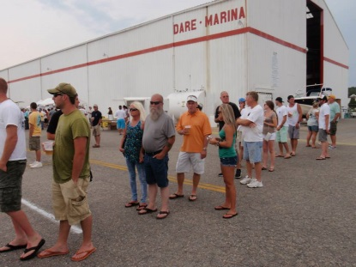Participants were treated to free food, beer and non-alcoholic beverages at the Captains meeting Friday night and again at the weigh in on Saturday. At the weigh in, the PSWSFA tournament crew served a seafood feast including fresh fish, scallops donated by Seaford Scallop Company and a variety of other foods and deserts. It would be hard to imagine anyone leaving the party hungry. Our sponsors donated multiple door prizes which were raffled off allowing everyone a chance to win. Raffle prizes were a Sheepshead mount donated by David Saunders of Mountain Breeze Taxidermy and artwork by Dr. Guy Harvey.

***Captain’s Meeting Kick-Off***

Our tournament is absolutely sponsor-driven, with donations from many businesses allowing for low entry fees and high payouts. In this tournament everyone has a chance to be a winner. Door prize tickets were included in each team’s registration package.

Many of our sponsors entered boats into the tournament and in the Sponsors Challenge Division. These boats competed in the regular tournament and also for the Sponsors Trophy that the winning business will display for the next year.

Tournament winners were determined by the combined weight of the team’s three largest fish. There was an optional 3 Fish Calcutta and Big Fish Calcutta which a combined sixty-nine boats chose to enter. The team with the most weight for each Calcutta won the pot. There were also awards for the largest flounder caught by a youth and by a lady. All teams not finishing in the top six places were entered into a “lucky dog” 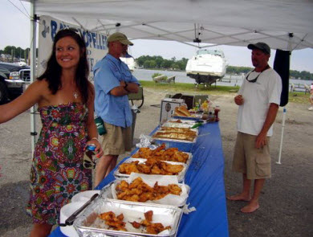drawing for a $500 prize.

Dedication was shown by the anglers in 2013 to deal with the conditions that were given from Mother Nature. Flatfish were caught from buoy 42, the Cell, 36A, the Hump, Back River Reef, Cape Henry Wreck and the Chesapeake Bay Bridge Tunnel. Although fishing was good all over the lower bay, the Chesapeake Bay Bridge Tunnel was the place to be. Many of the tournament fish came from the Chesapeake Bay Bridge Tunnel. The 2013 tournament produced some fantastic catches and an even better tournament celebration.

*A Seafood Feast for Everyone!*

***Another Fantastic Flounder Bowl In 2013!***

***2013 Tournament Results***

The 2013 Flounder Bowl champions are Brian Hogge and team Hog Choker. Their 3-fish stringer weighed in at 15.85 pounds. Brian's largest fish weighed 6.24 pounds. This fish won both the Big Fish Calcutta and the PSWSFA Member Award. Team Hog Choker's total winnings were $10,700. Brian becomes the first repeat Flounder Bowl Champion. He won his first championship during the 2010 Flounder Bowl.

The second place boat was the Hounddog with Richard Lewis. Their stringer weighed 13.31 pounds. They won $2,000.

Third place was Barry Bradley on the Fatty Flatty. They also won the 3-Fish Stringer Calcutta with their 12.62 pounds. Their total winnings were $3,700.

Just Plumbing sponsored the fourth place team. Zachery Hoffman on the Salt Treated weighed in a stringer of 12.5 pounds. Fishing on the Salt Treated was the Top Lady Angler, JJ Hensel. Her winning flounder weighed 4.69 pounds. She received $100 and a pair of Costa sunglasses. Salt Treated's total cash winnings were $1,100 and Just Plumbing gets to keep the Sponsors Trophy for the next year.

Coming in fifth place was Malcolm Covington and the Sweet Caroline. They weighed in 12.44 pounds and won $500.

In sixth place was Kenny Hoffman on the M & M Custom Painting team. Their 11.27 pound stringer won $250.

The Top Youth Angler was Fisher Dedmond with a 5.69 pound flounder. He was fishing on Cindi "D" sponsored by Bishop Fishing Supply. Fisher won $100 and a pair of Costa Sunglasses.

**Teams not placing in the top six were placed into a drawing for a "Lucky Dog" award. This year's winner is Cindi “D”. They won $500.00.**

**Total payout was $16,750 plus merchandise donated by our many wonderful sponsors. The businesses supporting this tournament make this event possible. The prizes that were raffled were artwork donated by Dr. Guy Harvey and a Sheepshead mount donated by Mountain Breeze Taxidermy. All of the other donated merchandise was given out via door prize tickets included with team registration.**

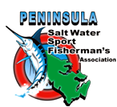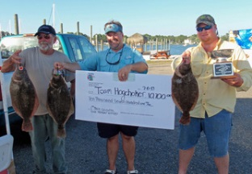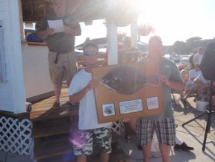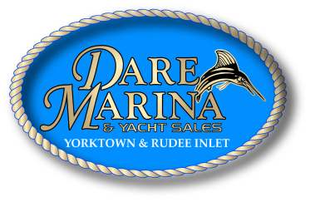

***2013 Tournament Winners***

|  |  |  |
| --- | --- | --- |
| ***Dare Marina***  ***and Yacht Sales*** | ***Multi-Print Inc.*** | ***C.A. Barrs***  ***Contractors*** |
| ***Bay Propeller*** | ***Boat U.S.*** | ***Yorktown Materials*** |
| ***Douglas Aquatics***  ***(in Memory of Eric Arnold)*** | ***POMOCO Auto***  ***Group*** | ***York River***  ***Electric Inc.*** |
| ***The Rod Father***  ***Bait and Tackle*** | ***Plastic Surgery Center of Hampton Roads***  ***Randy Blanchard, MD*** | ***Parks Orthodontics*** |
| ***Comfort Technology Heating & Air Conditioning*** | ***Wanchese Fish Company*** | ***Seaford Scallop***  ***Company*** |
| ***Michael Survey & Mapping PC*** | ***Thomas E Wilson***  ***Insurance*** | ***Green Top Outdoors*** |
| ***Harbor Mechanical*** | ***M&M Custom***  ***Painting*** | ***Mercury Mulch***  ***Inc.*** |
| ***Liebherr Mining***  ***Equipment*** | ***Riverwalk & Water***  ***Street Grille*** | ***VirginiaBeach***  ***Sportfishing.net*** |
| ***The Bush Companies*** | ***Ferguson Enterprises*** | ***Whitehouse Cove***  ***Marina*** |
|  | ***Auto Solution*** |  |

# *Our 2013 Flounder Bowl Gold Sponsor Team*

# *Our 2013 Flounder Bowl Silver Sponsor Team*

|  |  |  |  |  |  |  |  |
| --- | --- | --- | --- | --- | --- | --- | --- |
| ***Rudee’s Inlet Station Marina*** | ***Bishop Fishing Supply*** | ***Sinkerman’s Wholesale Sinkers & Lures*** | ***Flor De Cana Rum*** | ***Dock 2 Sea*** | ***Dr. McGillicuddy’s***  ***Liqueur*** | ***Ace Peninsula Hardware*** | ***Auto Haus*** |
| ***Hunt Smile Design*** | ***Beachcomber Restaurant*** | ***Yorktown Pub*** | ***Pig Out BBQ*** | ***Aero Colours Auto Body & Paint*** | ***Oyster Cove Boatworks & Yacht Brokerage*** | ***Dr. K. E. Neill*** | ***Just Plumbing*** |
| ***Appleton Rum*** | ***Wayne Harbin Builders*** | ***Sea Tow Lower Chesapeake*** | ***Amory Funeral Home*** | ***Williams Facility Services*** | ***Bluewater***  ***Yacht Sales*** | ***Coca Cola Refreshments*** | ***Drucker & Falk Real Estate*** |
| ***Catchin’ with***  ***Capt. Reese*** | ***Tidewater Family Dentistry*** | ***Chesapeake Angler Magazine*** | ***Fishing Tidewater WHKT 650 AM*** | ***Hibbard Iron Works*** | ***Peninsula Salt Water Sport Fisherman’s Association*** | ***Mountain Breeze Taxidermy*** | ***Holland Corp.*** |
| ***Wallace’s Bait & Tackle*** | ***Cactus Restaurant*** | ***Geary Family & Cosmetic Dentistry*** | ***Mark's Glass*** | ***Back River Rods*** | ***Teagle Insurance Agency*** | ***Costa Del Mar*** | ***Reel Fast Tackle*** |
| ***Pop’s Drive-In*** | ***Atlantic Marine Service*** | ***Southern Plumbing & Heating Supply*** | ***Bill’s Seafood House*** | ***Humps Contracting*** | ***Firefly Sweet Tea Vodka*** | ***CFE Equipment Corporation*** | ***West Marine*** |
| ***VooDoo Tackle*** | ***Dr. Guy Harvey*** | ***The Pizza Shop*** | ***Skyy Vodka*** | ***James Frasor Coastal Art*** | ***Grafton Fishing Supply*** | ***Re-Max Peninsula Lila Nicholls Inc.*** | ***ASI Security*** |

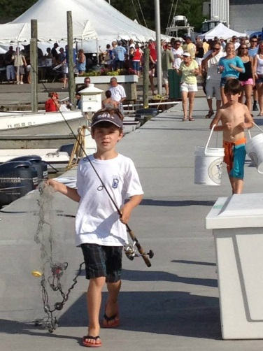

***The Flounder Bowl and Dare Marina are family friendly. While the festivities are in progress, the kids “fish” for a favorite critter, the Blue Crab. Obviously, they had some success and a great time!***

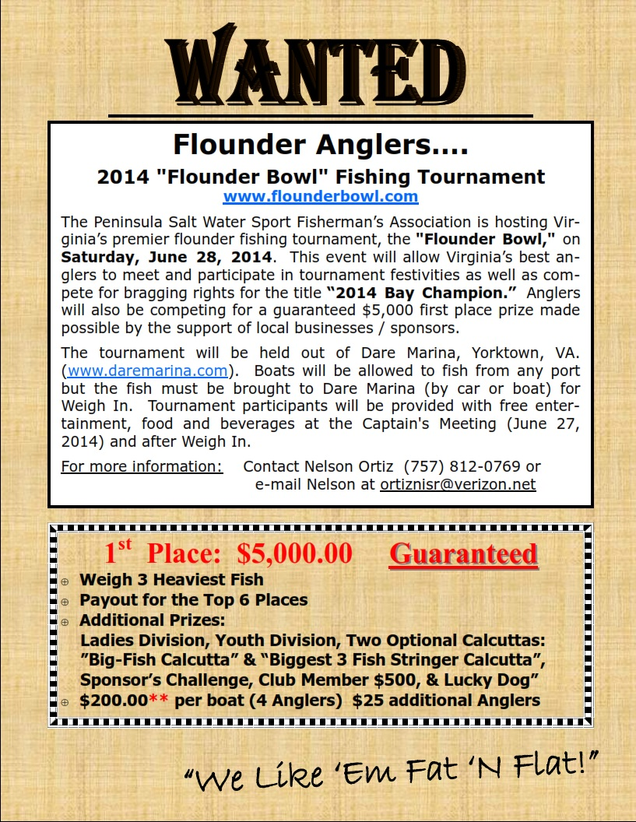

**2014 Flounder Bowl Tournament Rules:**

1. Official tournament starting time is 6:00 AM (lines in the water) on June 28, 2014 and will terminate at 5:00 PM that same day. You can leave from any port. Fish can be brought by car or boat but must be weighed at Dare Marina and you must be standing in the weigh-in line by 5:00 PM.
2. There will be a tournament meeting on Friday, June 27, 2014 7:00 PM, at Dare Marina. At least one member from each team must attend.
3. This is a boat tournament. Each boat may weigh-in up to 3 flounder. Winners will be determined by the combined weight of the team’s fish. Entry fee for each boat is $200 up to 4 anglers, $25 each additional angler. Early Bird Entry $125 if received by June 14th.
4. Teams must be registered prior to 6:00 AM of the day of the tournament. Proof of tournament registration must be presented to the weigh master when entering fish.
5. Fish must be caught by rod and reel only.
6. All fish are subject to thorough examination, both external and internal by the tournament committee of the PSWSFA.
7. In the event of a tie, the first team checked in at the weigh-in will be declared the winner.
8. Anglers are urged to display proper boat handling and courtesy towards others.
9. Anglers are advised to maintain an active weather watch when fishing Virginia’s waters. The captain and crew must decide on their own when and where to fish during this tournament and they are solely responsible for their safety.
10. Anglers will be required to submit to a sworn affidavit, if asked, and take a lie detector test, if deemed necessary, which will be provided by the tournament committee. These may be required at any time and for any reason deemed appropriate by the tournament committee.
11. Anglers are responsible for all applicable taxes on prizes received. Winners shall allow the PSWSFA and the sponsors the opportunity and right to film, videotape, record, and photograph the winners and to use the prize winner’s name, voice and likeness without further compensation for advertising and promotion of the PSWSFA and the sponsors.
12. All participants agree that the PSWSFA, Dare Marina, and any sponsor of this tournament shall not be liable for injury, loss, or damage of any kind resulting from participation in this tournament or from the acceptance or use of any awarded prize.
13. Any protest must be filed by 5:30 PM on the day of the tournament. The protest must be made directly to an official of the tournament committee. The tournament committee will review any and all protests and their decisions will be final.
14. No fish caught during the act of commercial fishing will be eligible.
15. Any fish entered in or with another contest or tournament, outside of the PSWSFA, shall be ineligible for entry into this tournament.
16. Any contestant found guilty of cheating, attempting to cheat, or otherwise deviating from the regulations of this tournament, shall be disqualified and considered ineligible for further and future participation and will be prosecuted.
17. Tournament committee members are not eligible to fish in this tournament. They will be identified at the Tournament Meeting on June 27, 2014.
18. The Tournament Committee shall consists of a minimum of three people; a director and two assistants all sanctioned by the PSWSFA.
19. If small craft advisories are posted at 5:00 PM the day before the tournament for the day of the tournament, for the area from New Point Comfort to Little Creek, the tournament will be postponed until the next "blow date." The scheduled blow day will be Sunday, June 29, 2014. Small craft advisory information shall be as announced by NOAA and obtained from the weather channel on marine VHF radio. Next blow day would be the following Saturday.
20. Fish that will be entered into the tournament **must be tagged** with tags that will be supplied at the tournament meeting.
21. There will be an optional big fish Calcutta with an entry fee of $100 per boat. The single heaviest fish wins. You must tag your Calcutta fish with the special tag provided. In case of a tie, the first fish weighed will be declared the winner.
22. There will be a second optional "stringer" calcutta for $100 with a 100% payout to the heaviest stringer entered in this calcutta.
23. 1st Place: $5,000.00 guaranteed, 2nd Place: 30% not to exceed $2,000.00, 3rd Place: 20% not to exceed $1,500.00,
24. 4th Place: 10% not to exceed $1,000.00, 5th Place: 5% not to exceed $500.00, 6th Place: 5% not to exceed $250.00, “Lucky Dog”: $500.00, “PSWSFA Member: $500.00.
25. Sponsors Challenge Division - $250, Sponsor will be entered into the regular division and separate sponsor’s division.
26. “Lucky Dog” payout –10% of regular entries up to a maximum of $500.Teams not placing in the top 6 will be entered into a "Lucky Dog" drawing. A member of the team must be present to win. If no member of the winning team is present, another team will be drawn.
27. Ladies Division – The largest fish wins $100.00. In case of a tie, the first fish brought in will win. Fish may also be entered in main event.
28. Youth Division – children 15 years old and under may participate. The largest fish wins $100.00. In case of a tie, the first fish brought in will win. Fish may also be entered in main event.
29. Club Member $500 Division - The club member with the largest fish wins $500.00.

- - - - - - - - - - -cut here - - - - - - - - - - - - - - - - - - - - - - - - cut here - - - - - - - - - - - - - - - - - - - - - - - -cut here - - - - - - - - - - -

**PSWSFA 2014 Flounder Bowl Registration Form**

Name:__________________________ Date:___________________

Calcutta  / 3-String Calcutta  / Lady  / Youth  / Club Member $500  / Lucky Dog  / Sponsor 

Address:__________________________________________________________

City:_____________________________________________State:_____ Zip:_______________

E-mail address: ______________________________Boat Name: ________________________

Captain: ________________________________ Captain's Phone Number: ________________

Crew Members:________________________________________________________________

Signature:____________________________________________________________________

Register and pay on-line at flounderbowl.com. Early Bird ($125) by June 14th or Late Registration ($200) after June 14th **or** mail to: PSWSFA, P.O. Box 5194, Newport News, VA 23605 **or** bring form to the Captain’s Meeting on June 27th.

LIMITED TO 120 BOATS

# *Special Thanks*

